Pottery
Assignment #2 “5 Textures Tile”
Visual Art Standards:
B.V.2.2 Understand the relationships between sensory awareness and artistic expression.
B.V.3.2 Use a variety of media, including 2-D, 3-D, and digital, to produce art.
B.CX.2.3 Analyze the collaborative process in the creation of art.

Vocabulary:
Motif: single unit/element
Pattern: motif(s) repeated more than twice in a predictable manner/rhythm
Texture: how something feels
Sculpture: 3-D visual art form
Variety: principle of design; differences
Score: roughen the surface of clay
Additive: add onto the surface of clay
Slab: use rolling pin to create even thickness of clay
Learning Task:
Illustrate a single motif pattern in a regular repeating rhythm
Illustrate a double motif pattern in an alternating rhythm

Materials: clay, cloth, rolling pin, paper clip/felting knife, slip, pencil, notebook, cleaning supplies, template, tempera paint, sponge (use what you need to complete your tasks)

Steps:
DAY 1
- Set up one page in your sketchbook for Texture tile. Then…. CHOOSE: Would you like to work alone or in a group of 4 or 9? You will only be personally responsible for one tile, but if you choose to work as a group, your groups tiles will have to create one cohesive image when all 4 or 9 tiles are arranged into the larger square.
- Create a design (alone or working in your group) that divides EACH individual tile into 4 -6 areas. I recommend a subject that naturally has a lot of lines/shapes or a non-objective design based on line/shape. Document your planning with photos and design doodles.
- Trace tile template into your sketchbook page for the final design of your square. Draw the lines that divide your square into 4-6 areas (use curved or straight lines but no jagged zig-zaggedy lines)
- Brainstorm/sketch into your planning page at least 8 patterns- ½ with a single motif, ½ with double motif. Try to make each using a tiny bit of play-doh. Circle the patterns that you can “translate into 3-D.” Share your successes with your group/table. Make additions to your brainstorming based on what your peers have shared with you. You will need at least 6 patterns to choose from that can “go 3-D.”
- Choose a pattern for each section of your design. FOR THOSE WORKING IN GROUPS- you need to ensure the pattern you use in any area that links up to a partner’s area is similar in size and rhythm.
- Get a 6” square piece of drawing paper from Ms. Cave. Trace the tile template in the center. Transfer your design (with 4-6 sections) onto the white drawing paper. Draw a different texture onto each section. Use BLACL INK with three thicknesses of line for variety. When you are finished take a photo and save in your sketchbook for later
Day 2
- Get your tile and some clay to make the patterns. Remember clay only joins to clay when it is still damp and easy to mold. So keep all clay not in use in a plastic bag! Add damp (not drippy) paper towels to keep the clay damp from day to day. Keep the tile on a flat surface at all times.
- Use a dull pencil & draw sections onto clay (lay the design on the clay and gently trace over the section lines- it will leave a slight indent on the clay surface). Cover your tile up with plastic.
- Using tiny pieces of clay make the motifs of the pattern in section #1. Make a lot. Then score the surface of section #1 (scratch it with your pencil point so it is slightly rough). Using your finger add a thin layer of slip (watery clay) and carefully place each clay motif in place pressing each down gently until the slip oozes up a bit.
- REPEAT FOR EACH SECTION- Create, then score & slip textures onto each section.
- GROUPS- occasionally check to make sure the tiles are still aligning to show the one cohesive image as you work.
- Let dry on the shelf in the back room (GROUP- w/ others from your group all arranged correctly)
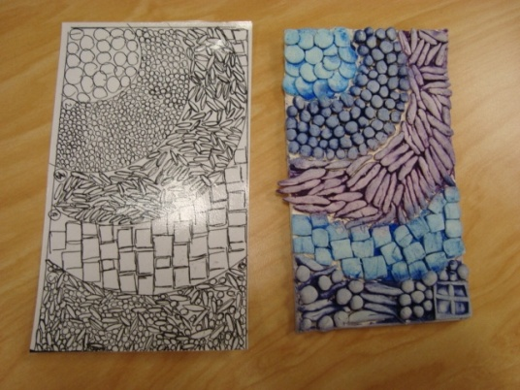H. Rion
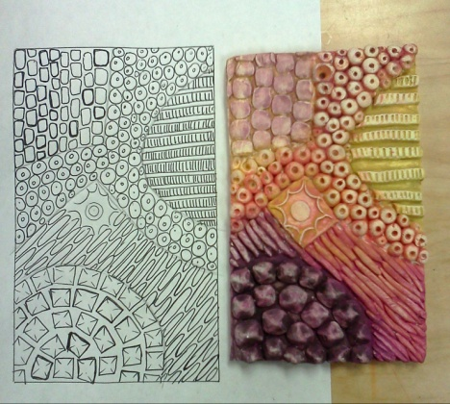 J. Cave 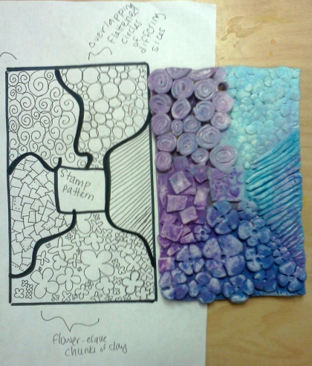 student work
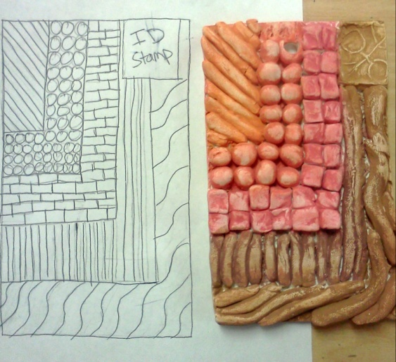 student work

