The CRITICAL METHOD
In order to go beyond the question, “Is it Art” to “Is it good art?,” we must have a rationale which will help us answer this. Is it simply a matter of using the elements of art and principles of design? Is it?
Following the Critical Method to write a criticism of an artwork is like this:
- Follow all four steps in order.
- Write (correct spelling, grammar and high school level word choice) 1-2 complex sentences to address each step.
- A standard level criticism of any work should be at least one detailed, long paragraph.
- An extension level criticism will be more essay style (4-5 paragraphs) a page to a page and a half with multiple specific references to the artwork to support statements made in the body of the work.

Describe What do you see?
First of all, what type of artwork is this? (sculpture, movie, painting, drawing…etc.) How does it look? What events are taking place (time of day, social events, etc)? Identify what is easily apparent to see and only state the FACTS.

Analysis How is it organized?
When you analyze an artwork, you tell how the subject matter and elements of the work have been organized by the artist. How do the elements and design principles influence the composition? Which ones are strong and which ones are weak? Are the elements and principles being used appropriately?
- Elements: Color, Value, Shape, Form, Space, Line, Texture (chose 1-2 to focus on)
- Principles: Balance, Emphasis, Pattern, Rhythm, Variety, Unity (chose the most apparent one)

Interpret What is the mood, message, and/or meaning?
Use the information from your description and analysis to help you identify the meaning of the work – what does it tell YOU about the human experience? Does the work raise questions about art or life? Does it relate to any kind of culture? What objects does the work remind you of? Talk about your own experiences that may relate to the work. Most importantly you should be able to develop some sort of meaning from the work. This is the place for opinions.

Evaluate Is it successful?
One word responses do not work here. You need to support your decision by using facts that you have collected from the work by talking about them in your writing. Start off by asking yourself, is the work completed well, or is the work poorly done, and how? Does the work communicate good design principles and/or elements?
Does it try to imitate the real world (Representational)? Is the work an abstraction of the real world (Abstract)? If the work does not represent anything from the real world then it is Non-objective? To what extend does the work hold your attention, arouse curiosity, or make you think?

Now its your turn…
On the back I have written a critique of a work by Picasso we learned about in early in the semester. Next to it, you will attempt to gather your thoughts to write on about The Old Guitarist. This is a planning page and you should have more bullets of information rather than complete sentences.

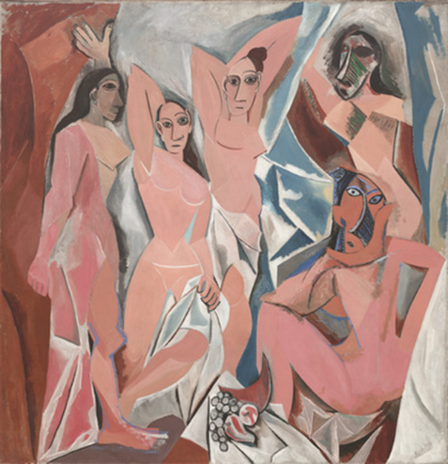
Picasso, Demoiselles d’Avignon, 1907

Describe
The oil painting, Demoiselles d’Avignon, by Picasso shows five female figures. Four figures are standing while one is seated.

Analyze
Picasso chose to use complementary dull blues and flesh tones in the irregular shapes both the figures and background are comprised of. The eye seems to travel rhythmically between the few areas of dark blues and oranges.

Interpret
I get the sense of looking at these women by way of a broken mirror. I feel as if Picasso is allowing me to look at them but yet holding back some information.

Judge
The abstract composition of Demoiselles d’Avignon was and is a groundbreaking achievement in the history of art. The movement created by the repeated use of color and the imaginative ideals expressed in the abstracted forms of the women are as successful in 2015 as they were in 1907.
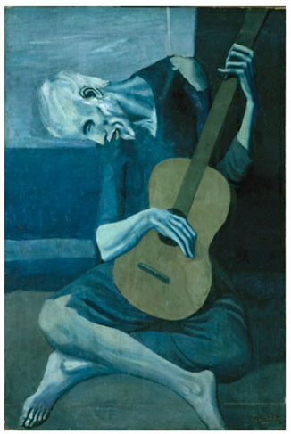
Picasso, Old Guitarist, 1904

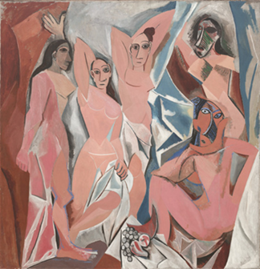
Picasso, Demoiselles d’Avignon, 1907 Picasso, Old Guitarist, 1904
Picasso, Demoiselles d’Avignon, 1907 Picasso, Old Guitarist, 1904

