Not Just for Art Class Artist Research Project
Name of the Artist __________________________ Title of artwork __________________________
**copy all research into your sketchbook**

1. When did the artist live? (dates) Where did they live for the majority of their career? What culture were they a part of?
2. To what "school" of art or “movement” did the artist belong? Who was another artist from the same "school" of art?
3. The artist is best known for creating art in which visual art form?
4. Does this artist have a theme to their body of work? If so, why do you think that was the artist chose that concentration/message?
5. Looking at several pieces of this artist's work, Choose ONE work that you think is the BEST example of their work. Write a critical analysis using the critical method.

6. How did this artist document human experience of their time?
7. What other course in school would this artist/artwork be a great fit for? Why? Give an example of how the work could be used to teach a topic in that class.
8. Cite at least two reputable resources for your research.
9. What kind of creative technology will you use to make your presentation? (technology: tools human invent/use to help them)
10. Sketch the design idea for the presentation.

NOTE: For the opportunity to earn a high grade (A) you must meet use new technology or atypical presentation technology. Highest possible score if you choose to use PowerPoint, Presi or Google Slides is an 89. AND if you choose to write a paper your highest possible grade is a 79.
TIMELINE: We will have 3 days in the media center to research and create the presentation.
March 21 (in class, last 20 minutes)- students take pre-assessment just looking at Ms. Cave’s chosen artwork, Ms. Cave demonstrates a quality presentation, students take post-assessment. Ms. Cave passes out project guidelines, research questions and grade rubric.
March 22 (in media center)-
Media Specialist presents available technology to help make a creative presentation, students draw an artist from a bowl (may draw up to 3 times), students begin research/planning in sketchbook. *Exit ticket – post artist name on CUBE windows under course name*
March 23 (in media center)- Students conclude research and begin crafting presentation - * Exit Ticket- post two bits of research that ties the artist/artwork directly to a specific topic under that course heading*
March 24 (in media center)- Students complete project & share product digitally with Ms. Cave (via Edmodo or Google Docs, extra time? Work on March 1 x 1’s
Presentations will be after Spring Break.

Creative Use of Technology Presentation Name __________________
Not Just for Art Class Artist Research Project Block _____ Date ________ Rubric for Art I
Objectives: Each worth 10 pts / 100 pts total
Must be 3 minutes in length ___
under or over by 1 min (-5) ___
under or over by 2 min (-8) ___
Information on Artist/Artwork is presented clearly (Questions 1-4)
Critical Analysis follows 4 –step procedure (Question 5)
Show examples of Artist’s work (Question 5 plus at least one more)
Explained clearly how the artist documented the human experience of their time AND how the experience fits into our time (Question 6)
Tie to NON-Visual Art course is CLEAR (Question 7, part 1)
Information on related topic is presented clearly (Question 7 parts 2 & 3)
At least 2 reputable sources included in presentation ( Question 8)
Identified the app/software/website/program used to create the work
(Question 9)
Presented on assigned day

Project Reflection Questions:
- What was the most difficult aspect of this creative use of technology project? Why?
- Did you collaborate with another student by being a production assistant? What exactly was your role in their presentation?

Artists for selection

Jean-Francois Millet | Kara Walker | Dorothea Lange | Maria Martinez
Edgar Degas | Banksy | Judy Chicago | El Anatsui
J. M. W. Turner | Andy Warhol | Sandy Skoglund | Norman Rockwell
Mary Cassatt | Salvador Dali | Johannes Vermeer | Chuck Close
Frida Kahlo | Rene Magritte | Jan van Eyck | Frederic Edwin Church
Diego Rivera | Michelangelo Buonarroti | Francisco de Goya | Thomas Cole
Dale Chihuly | Paul Cezanne | Takashi Murikami | Kehinde Wiley
Kathe Kollwitz | Gordon Parks | Louise Nevelson | Giuseppe Arcimboldo
Georgia O’ Keeffe | Pierre- Auguste Renior | Edward Hopper | James Whistler
Wassily Kandinski | Albrecht Durer | Gustav Klimt | Alexander Calder
Jackson Pollock | Marc Chagall | M. C. Escher | Diego Velazquez
Katsushika Hokusai | Henri Matisse | Ursula Von Rydingsvard | JR (street artist)
Vic Muniz | Yves Tanguy | David Smith | Robert Maplethorpe

ASW – Spring 2016
NCSCOS B. CX. 1.3 – Understand how art is used to document the human experience.
Point 1

Pre-Instructional Assessment of Prior Knowledge _____________

You will have 7 minutes to complete and turn this work in ___________________

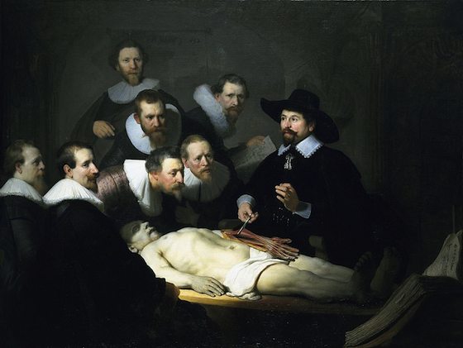

- What is the purpose of the above painting?

- Can you guess when it was painted? Draw a line and circle the area(s) that help you identify the time period in yellow colored pencil.

- Do you feel the artist was present and painted the image live? Why do you feel that way? If there is evidence in the image that supports your judgement, use a red colored pencil to circle that area.

- Do you think the artist was also a doctor or had personal interest in the field of medicine? Why do you feel that way? If there is evidence in the image that supports your judgement, use a blue colored pencil to circle that area.

- How does this work document the human experience of the time it was painted?

- How does it relate to human experience of today?

- What kind of textbook would you expect to find this painting in?

